INDEX

Sr. No | Title |  | Date |  | Signature
1 |  | Practical of Data  collection, Data curation and management for Unstructured data (NoSQL)
2 |  | Practical of Data collection, Data curation and management for Large- scale Data system (such as MongoDB)
3 |  | Practical of Principal Component Analysis
4 |  | Practical of Clustering
5 |  | Practical of Time-series forecasting
6 |  | Practical of Simple/Multiple Linear Regression
7 |  | Practical of Logistics Regression
8 |  | Practical of Hypothesis testing
9 |  | Practical of Analysis of Variance
10 |  | Practical of Decision Tree

Practical No. 1
Aim: Practical of Data collection, Data curation and management for Unstructured data (NoSQL)

Couchdb database --- rscript Install couchdb first
Rscript code install.packages('sofa') #devtools::install_github("rop ensci/sofa") library('sofa') #create
connection object x<- Cushion$n ew()
#to check whether object created x$ping() #create database ty db_create(x,dbna

me = 'ty')
db_list(x) #create json doc

doc1<-'{"rollno":"01","name":"ABC","GRADE":"A"}'

doc_create(x,doc1,dbname

= "ty",docid = "a_1")
doc2<-'{"rollno":"02","name":" PQR","GRADE":"A"}'

doc_create(x,doc2,dbname = "ty",docid = "a_2")

doc3<-'{"rollno":"03","name":"xyz","GRADE":"B","REMARK":"PASS"}'

doc_create(x,doc3,dbname = "ty",docid = "a_3")

#CHANGES FEED

db_changes(x,"ty")

#search for id > null so all docs will display db_query(x,dbname
= "ty",

selector = list('_id'=list('$gt'=NULL)))$docs

#search for students with grade is A

db_query(x,dbname = "ty",selector = list(GRADE="A"))$docs

#search for students with remark =pass

db_query(x,dbname = "ty",selector = list(REMARK="PASS"))$docs

#return only certain fields where rollno>2

db_query(x,dbname = "ty",selector = list(rollno=list('$gt'='02')),fields=c("name","GRADE"))$docs

#convert the result of a query into a data frame using jsonlite library("jsonlite")
res<-db_query(x,dbname = "ty",selector = list('_id'=list('$gt'=NULL)),fields=c("name","rollno","GRADE","REMARK"),as="json")

#display json doc fromJSON(res)$docs

#doc_delete(cushion,d bname,docid) doc_delete(x,dbname = "ty",docid = "a_2") doc_get(x,dbname = "ty",docid = "a_2")

doc2<-'{"name":"Sdrink","beer":"TEST","note":"yummy","note2":"yay"}'

doc_update(x,dbname = "ty",doc=doc2,docid="a_3",rev = "3- b1fb56db955b142c6efd3b3c52fe9e1b")

doc3<-'{"rollno":"0 1", "name":"UZMA",
"GRADE":"A"}'

doc_update(x,dbname = "ty",doc=doc3,docid = "a_1",rev = "1- be7c98bddf8ea7c46f4f401ff387593d")

Output:
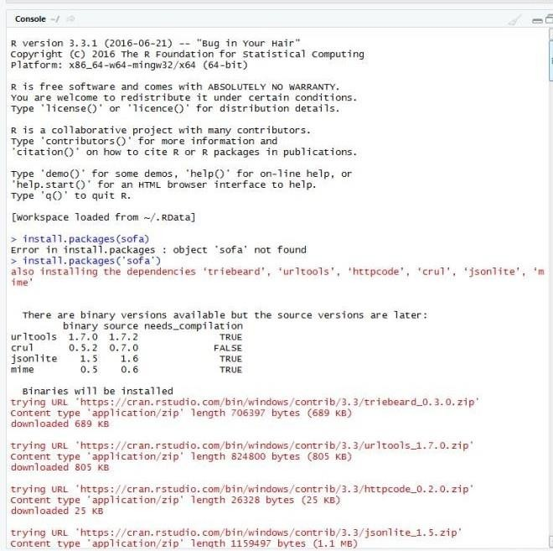

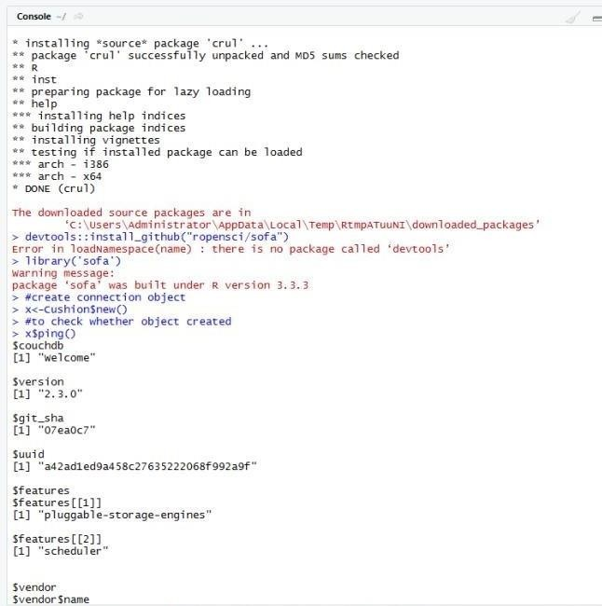

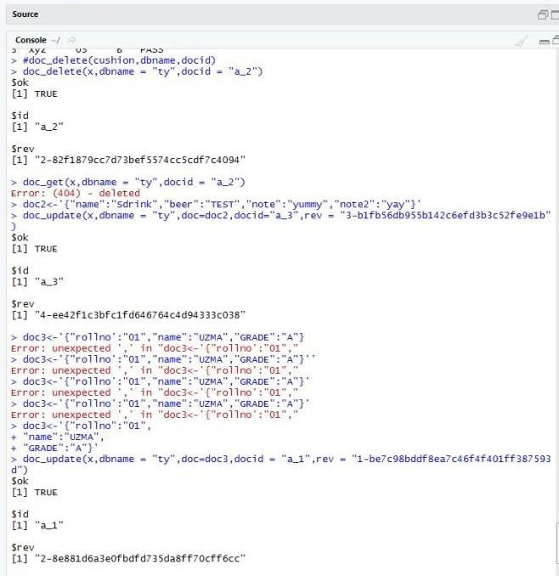

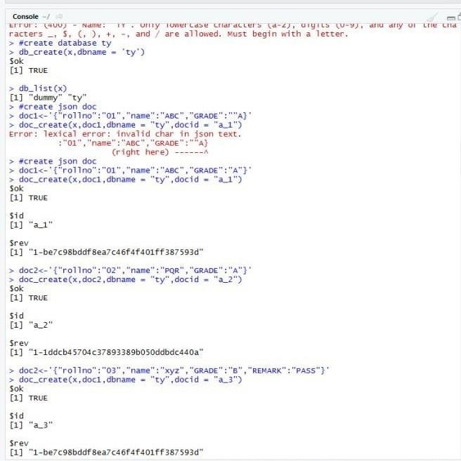

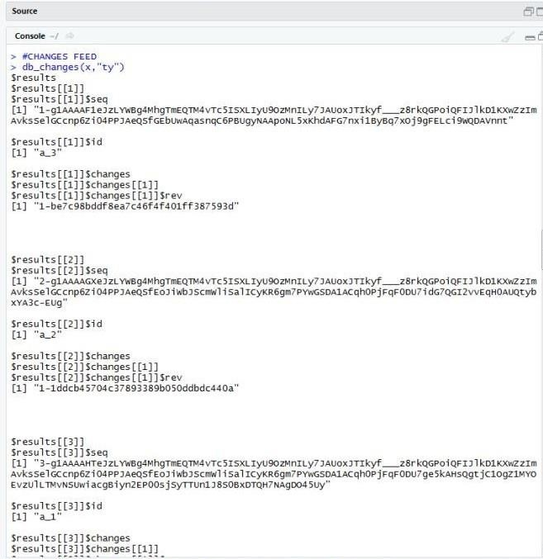

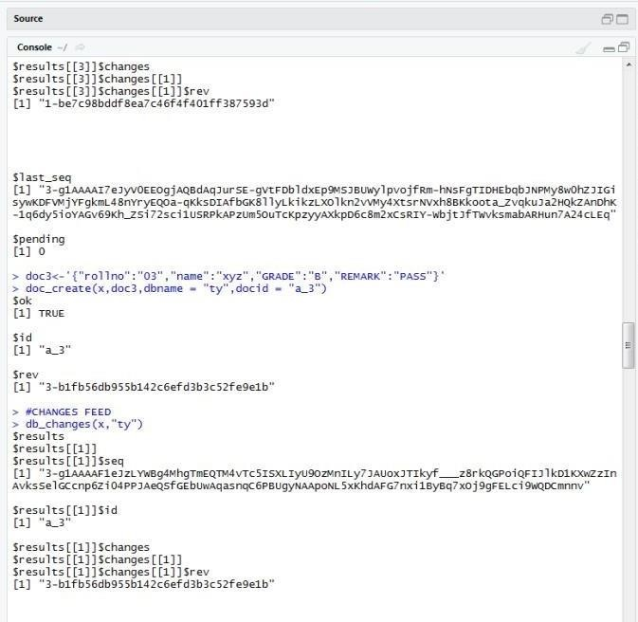

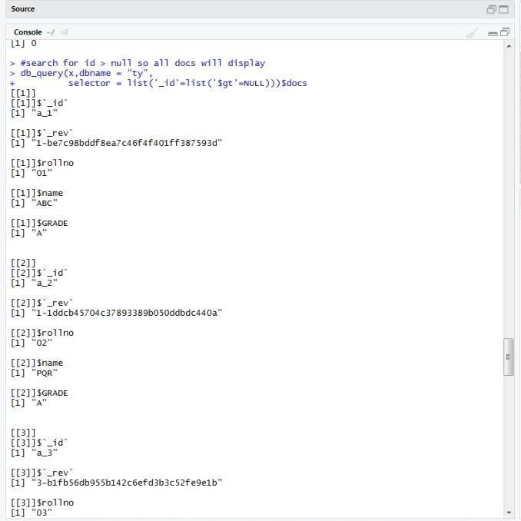
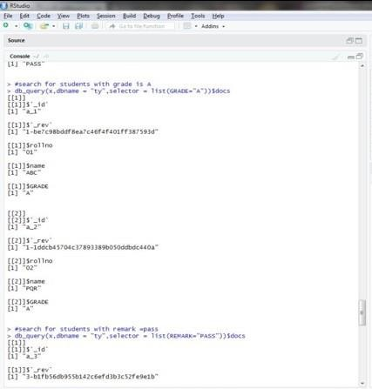

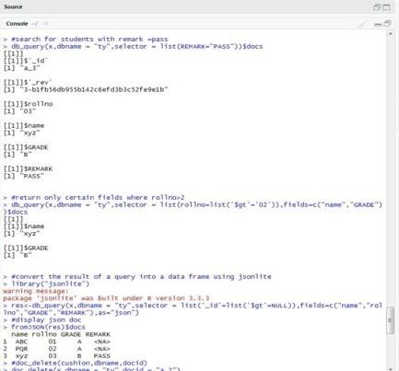

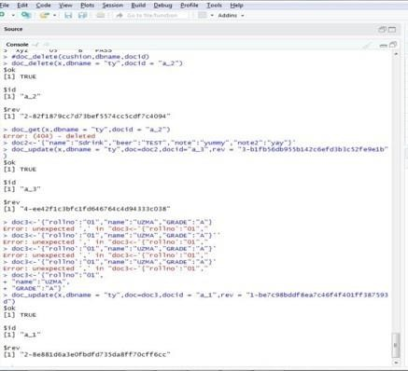

- MongoDB Create database
- MongoDB Drop Database
- MongoDB Create collection
- MongoDB Drop collection
- MongoDB Insert Document
- MongoDB Query Document
- MongoDB Update Document
- Delete document in MongoDB
- MongoDB Projection
- limit() and skip() method in MongoDB
- Sorting of Documents in MongoDB
- MongoDB Indexing

Starting server with mongo or mongodb C:\>mongo
>db Test

Create Database in MongoDB

Once you are in the MongoDB shell, create the database in MongoDB by typing this command:
use database_name

For example: create a database “tycs”:

- use tycs switched to db tycs

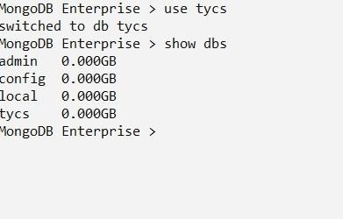

create a collection user and insert a document in it.
- db.user.insert({name: "Asif", age: 20})

O/P: WriteResult({ "nInserted" : 1 })

>show dbs admin 0.000GB config 0.000GB local
0.000GB
tycs 0.000GB

MongoDB Drop Database
The syntax to drop a Database is:
>db.dropDatabase()

O/P:
{ "dropped" : "Testdb", "ok" : 1 } MongoDB Enterprise > show dbs admin
0.000GB
config 0.000GB local 0.000GB tycs 0.000GB

O/P:
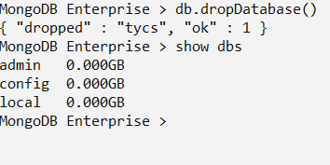

Create Collection in MongoDB
Method 1: Creating the Collection in MongoDB on the fly MongoDB Enterprise > use tycs
switched to db tycs

MongoDB Enterprise > db.tycs.insert({name:"Asif khan",age:21,website:"www.google.com"})

O/P:
WriteResult({ "nInserted" : 1 })

Syntax: db.collection_name.find()
MongoDB Enterprise > db.tycs.find()

o/p:
{ "_id" : ObjectId("5e410808e3755b1e06a63d1d"), "name" : "Asif khan", "age" : 21, "website" : "www.google.com" }

show collections
MongoDB Enterprise > show collections

O/P:
tycs user

Drop collection in MongoDB
SYNTAX:
db.collection_name.drop()

MongoDB Enterprise > use students switched to db students

MongoDB Enterprise > show collections
students teachers tycs user

MongoDB Enterprise > db.user.drop()
true
MongoDB Enterprise > show collections
students teacher tycs
MongoDB Insert Document
Syntax to insert a document into the collection:
db.collection_name.insert()

- db.tycs.insert(
... {
... name: "ASIF",
... age: 20,
... email: "asif@gmail.com",
... course: [ { name: "MongoDB", duration: 7 }, { name: "Java", duration: 30
} ]
... }
... )

O/P:
WriteResult({ "nInserted" : 1 })

Verification:
Syntax:
db.collection_name.find()

db.tycs.find()
{ "_id" : ObjectId("5c2d37734fa204bd77e7fc1c"), "name" : "ASIF", "age" : 20, "email" : "asif@gmail.com", "course" : [ { "name" :
"MongoDB", "duration" : 7 }, { "name" : "Java", "duration" : 30 } ] }

MongoDB Example: Insert Multiple Documents in collection MongoDB Enterprise

var beginners=
... [
... "studentID":1001,
... "studentName":"Asif",
... "age":20
... },
... ]

MongoDB Query Document using find() method
Querying all the documents in JSON format MongoDB Enterprise > db.students.find().pretty()

{
"_id" : ObjectId("5e410f3fe3755b1e06a63d1e"), "studentID" : 1001, "studentName" : "Asif", "age" : 20
}

Query Document based on the criteria
- db.students.find({StudentName : "Asif"}).pretty()

{
"_id" : ObjectId("5c281c90c23e08d1515fd9cc"), "StudentId" : 1001,
"StudentName" : "Asif", "age" : 20
}

  - Updating Document using update() method

Syntax:
db.collection_name.update(criteria, update_data)

- use tycs
switched to db tycs
- show collections beginnersbook students tycs

db.createCollection("got")
{ "ok" : 1 }
- var abc = [
... {
... "_id" : ObjectId("59bd2e73ce524b733f14dd65"),
... "name" : "Asif",
... "age" : 20
... },
... ];

db.got.find().pretty()
{
"_id" : ObjectId("59bd2e73ce524b733f14dd65"), "name" : "steve", "age" : 20
}

To update multiple documents with the update() method:
db.got.update({"name":"Jon Snow"},
{$set:{"name":"Kit Harington"}},{multi:true})

Updating Document using save() method

Syntax:
db.collection_name.save( {_id:ObjectId(), new_document} )
To get the _id of a document, you can either type this command:
db.got.find().pretty()
- db.got.find({"name": "Asif"}).pretty()
{
"_id" : ObjectId("59bd2e73ce524b733f14dd65"), "name" : "Asif", "age" : 20
}
- db.got.find().pretty()
{
"_id" : ObjectId("59bd2e73ce524b733f14dd65"), "name" : "Steve", "age" : 20
}

MongoDB Delete Document from a Collection Syntax of remove() method:

db.collection_name.remove(delete_criteria)

Delete Document using remove() method
- db.students.find().pretty()
{
"_id" : ObjectId("59bcecc7668dcce02aaa6fed"), "StudentId" : 1001,
"StudentName" : "Steve", "age" : 30
}

db.students.remove({"StudentId": 3333})

Output:

WriteResult({ "nRemoved" : 1 }) To verify whether the document is actually deleted. Type the following command:

db.students.find().pretty() It will list all the documents of students collection.

- use tycs
switched to db tycs
- db.students.find().pretty()
{
"_id" : ObjectId("5c281c90c23e08d1515fd9cc"), "StudentId" : 1001,
"StudentName" : "Asif", "age" : 20
}
{
"_id" : ObjectId("5c2d38934fa204bd77e7fc1d"), "StudentId" : 1001,
"StudentName" : "Steve", "age" : 30
}

Remove all Documents

db.collection_name.remove({})

MongoDB Projection Syntax:
db.collection_name.find({},{field_key:1 or 0})

- db.students.find().pretty()
{
"_id" : ObjectId("5c281c90c23e08d1515fd9cc"), "StudentId" : 1001,
"StudentName" : "Steve", "age" : 20
}
- db.students.find({}, {"_id": 0, "StudentId" : 1})
{ "StudentId" : 1001 }
{ "StudentId" : 1002 }

- db.students.find({}, {"_id": 0, "StudentName" : 0, "age" : 0})
{ "StudentId" : 1001 }
{ "StudentId" : 1002 }
  - MongoDB – limit( ) and skip( ) method
The limit() method in MongoDB

Syntax:
db.collection_name.find().limit(number_of_documents) db.studentdata.find({student_id : {$gt:2002}}).pretty() db.studentdata.find({student_id : {$gt:2002}}).limit(1).pretty()

MongoDB Skip() Method
db.studentdata.find({student_id : {$gt:2002}}).limit(1).skip(1).pretty()

  - MongoDB sort() method

Sorting Documents using sort() method

Syntax of sort() method:
db.collecttion_name.find().sort({field_key:1 or -1})
1 is for ascending order and -1 is for descending order. The default value is 1.

For example: collection studentdata contains following documents:
- db.studentdata.find().pretty()

{
"_id" : ObjectId("59bf63380be1d7770c3982af"), "student_name" : "Steve",
"student_id" : 1001,
"student_age" :1002
}

Let’s display the student_id of all the documents in descending order:
- db.studentdata.find({}, {"student_id": 1, _id:0}).sort({"student_id": -1})
{ "student_id" : 1001 }
{ "student_id" : 1002 }

To display the student_id field of all the students in ascending order:
- db.studentdata.find({}, {"student_id": 1, _id:0}).sort({"student_id": 1})
{ "student_id" : 1001 }
{ "student_id" : 1002 }

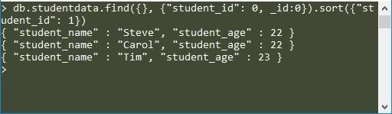

MongoDB Indexing with Example How to create index in MongoDB
db.collection_name.createIndex({field_name: 1 or -1}) The value 1 is for ascending order and -1 is for descending order.

Let’s create the index on student_name field in ascending order:

db.studentdata.createIndex({student_name: 1})

Output:
{
"createdCollectionAutomatically" : false, "numIndexesBefore" : 1,
"numIndexesAfter" : 2,
"ok" : 1
}

- MongoDB – Finding the indexes in a collection
db.collection_name.getIndexes()
- db.studentdata.getIndexes() [

{
"v" : 2,
"key" : {
"_id" : 1
},
"name" : "_id_",
"ns" : "test.studentdata"
},
]

Practical No. 3
Aim: Practical of Principal Component Analysis

data_iris<-iris[1:4] Cov_data<- cov(data_iris) Eigen_data<- eigen(Cov_data)
PCA_data<-princomp(data_iris,cor="False") Eigen_data$values PCA_data$sdev^2

PCA_data$loadings[,1:4] Eigen_data$vectors summary(PCA_data) biplot(PCA_data) screeplot(PCA_data,type="lines") model2=PCA_data$loadings[,1]
model2_scores<-as.matrix(data_iris)%*%model2 library(class) install.packages("e1071")
library(e1071)

mod1<-naiveBayes(iris[,1:4],iris[,5]) mod2<- naiveBayes(model2_scores,iris[,5]) table(predict(mod1,iris[,1:4]),iris[,5]) table(predict(mod2,model2_scores),iris[,5])

Output:

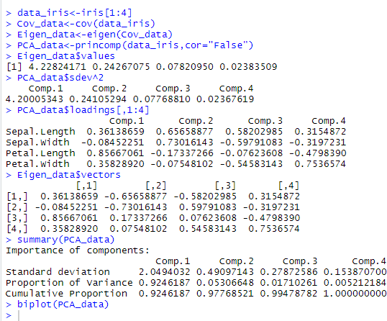

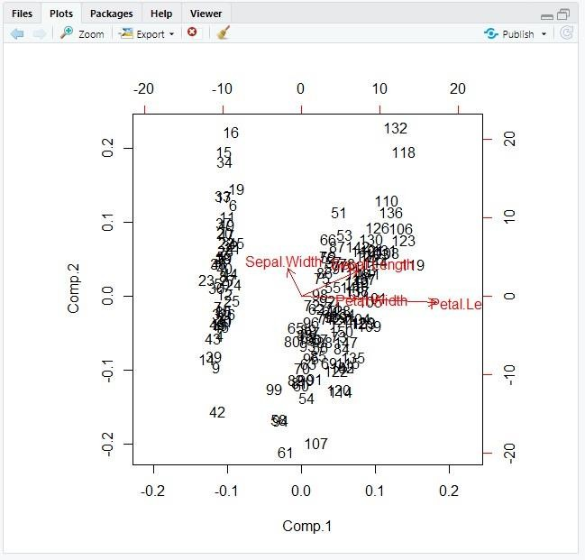

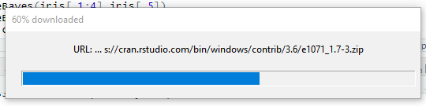
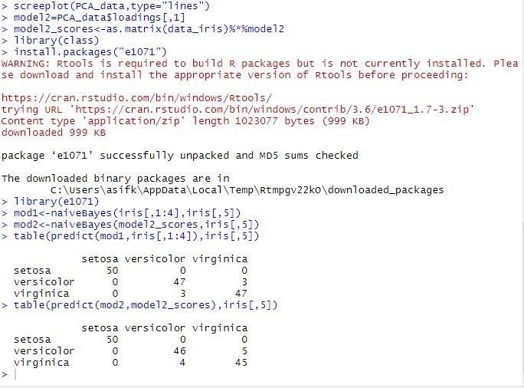

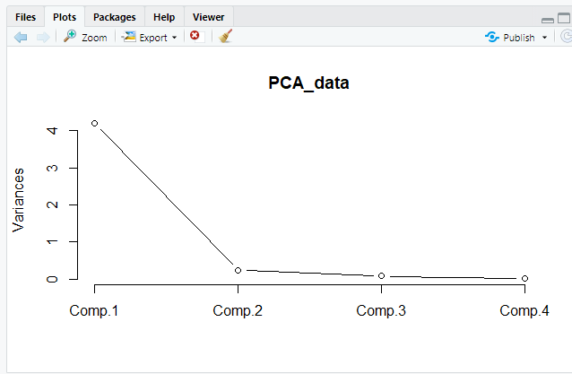

Practical No. 4
Aim: Practical of Clustering
"K-means Clustering " data(iris) names(iris)
new_data<-subset(iris,select = c(-Species)) new_data cl<-kmeans(new_data,3) cl
data<-new_data
wss<-sapply(1:15,function(k){kmeans(data,k)$tot.withinss}) wss
plot(1:15,wss,type="b",pch=19,frame=FALSE,xlab ="Number of clusters K",ylab = "Total within-clusters sums of squares")
library(cluster) clusplot(new_data,cl$cluster,color=TRUE,shade=TRUE,labels=2,lines= 0) cl$cluster
cl$centers
"agglomarative clustering " clusters<- hclust(dist(iris[,3:4])) plot(clusters) clusterCut<-cutree(clusters,3) table(clusterCut,iris$Species)

Output:
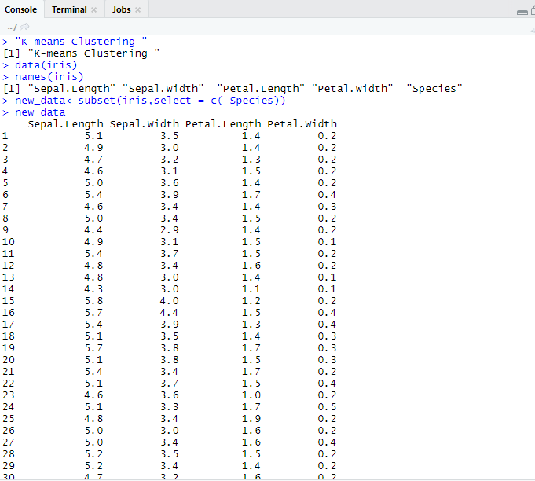

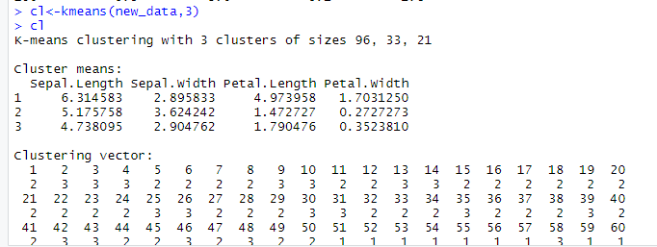

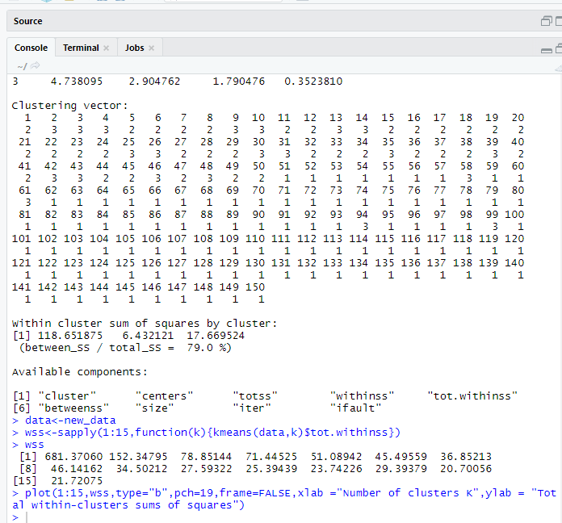
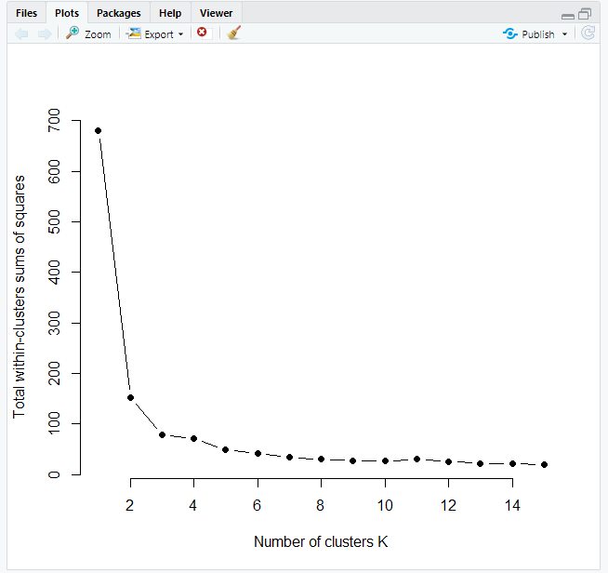

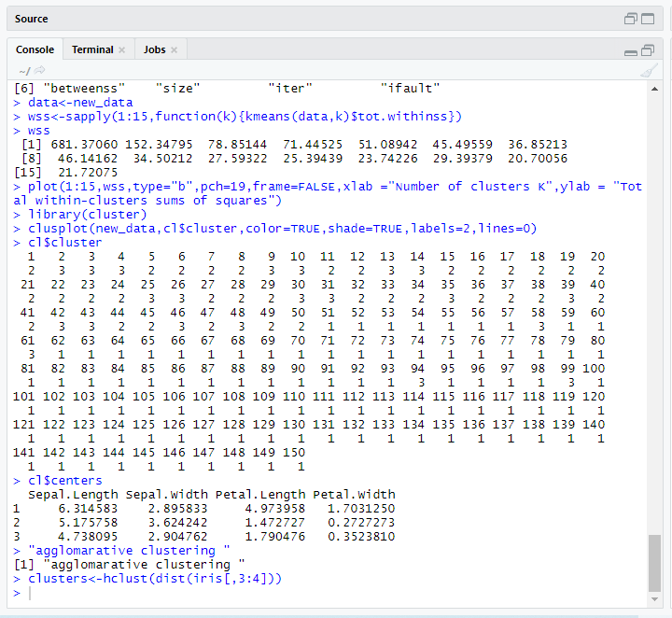

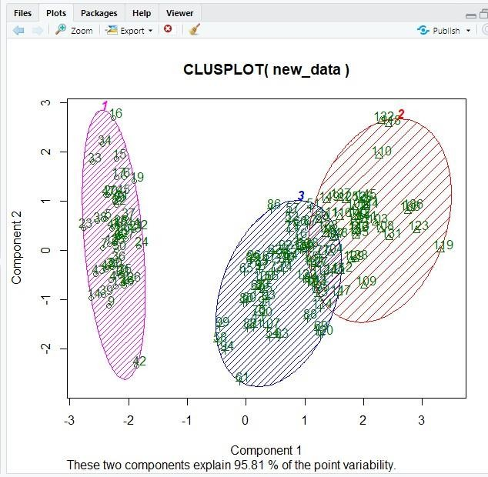

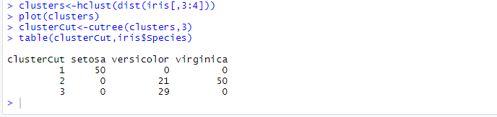
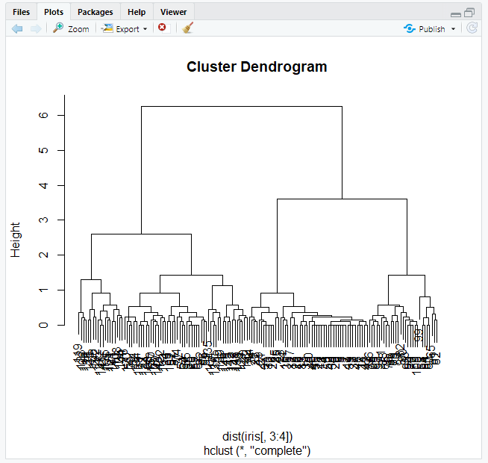

#consider the inbuilt data set Air Passengers data("AirPassengers") class(AirPassengers)
Practical No. 5
Aim: Practical of Time-series forecasting
start(AirPassengers)
#to know the end of time series end(AirPassengers) frequency(AirPassengers)
#to know the mean median etc of the dataset summary(AirPassengers)
#to plot the time series model plot(AirPassengers)
abline(reg=lm(AirPassengers~time(AirPassengers))) cycle(AirPassengers) plot(aggregate(AirPassengers,FUN=mean)) boxplot(AirPassengers~cycle(AirPassengers))

Output:

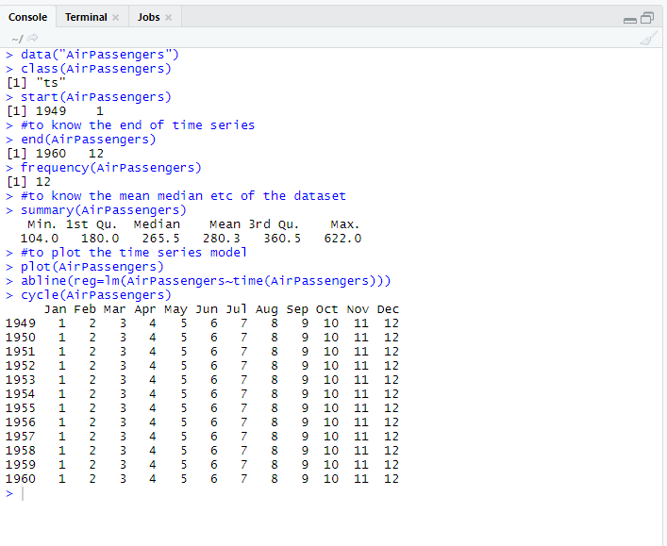
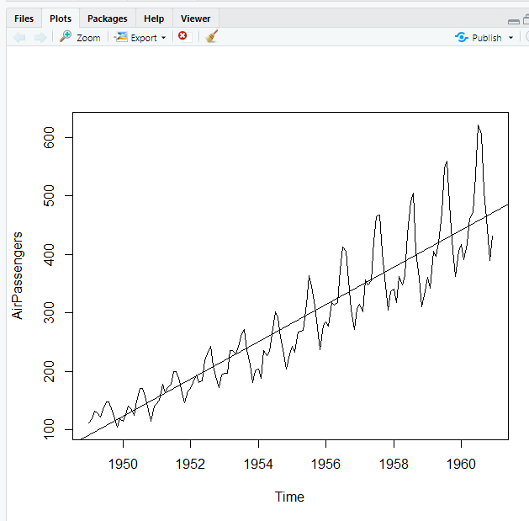

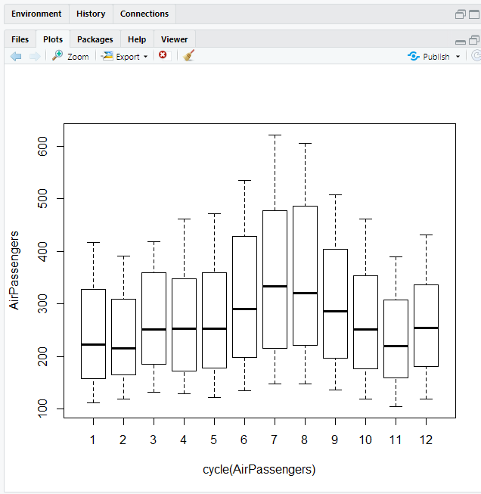

Practical No. 6
Aim: Practical of Simple/Multiple Linear Regression
#consider some data set height<-
c(102,117,105,141,135,115,138,144,137,100,131,119,115,121,113) weight<- c(61,46,62,54,60,69,51,50,46,64,48,56,64,48,59)
#lm is for Linear Regression student<-lm(weight~height) student #to predict use predict command
predict(student,data.frame(height=199),interval="confidence") #to plot the data plot(student)

Output:

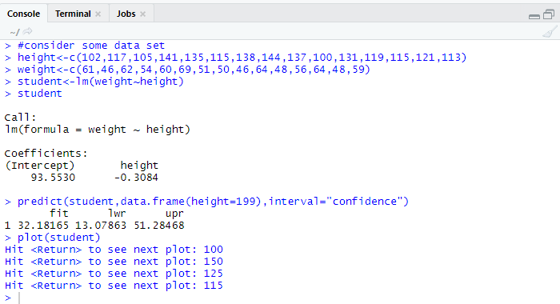
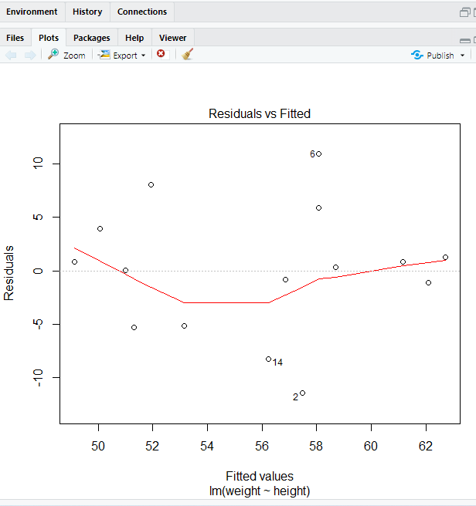

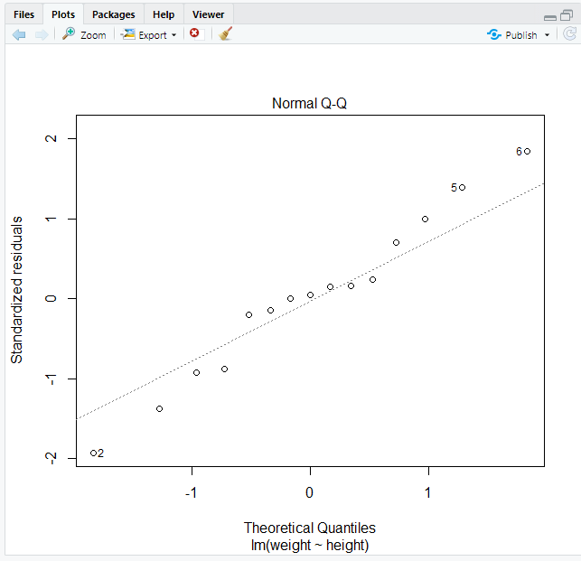

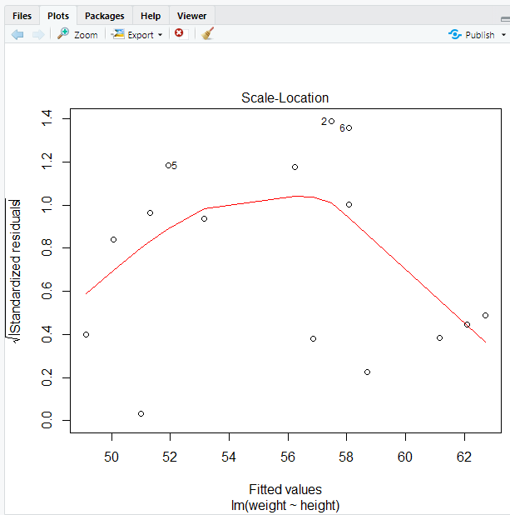

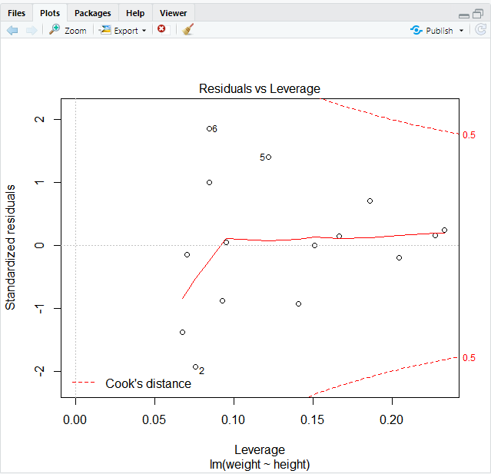

Practical No. 7
Aim: Practical of Logistics Regression

library(datasets) ir_data<-iris head(ir_data) str(ir_data) levels(ir_data$Species) sum(is.na(ir_data)) ir_data<- ir_data[1:100,] set.seed(100) samp<-sample(1:100,80) ir_test<- ir_data[samp,] ir_ctrl<-ir_data[- samp,] install.packages("ggplot2") library(ggplot2) library(ggplot2) install.packages("GGally") ggpairs(ir_test)
y<-ir_test$Species;
x<-ir_test$Sepal.Length glfit<-glm(y~x,family='binomial') summary(glfit)
newdata<-data.frame(x=ir_ctrl$Sepal.Length) predicted_val<-
predict(glfit,newdata,type="response")
prediction<- data.frame(ir_ctrl$Sepal.Length,ir_ctrl$Species,predicted_val) prediction

qplot(prediction[,1],round(prediction[,3]),col=prediction[,2],xlab='sepal. Length',ylab='prediction using logistic Reg')

Output:
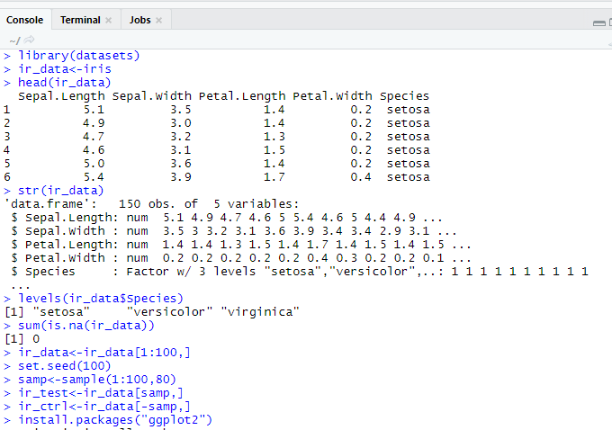


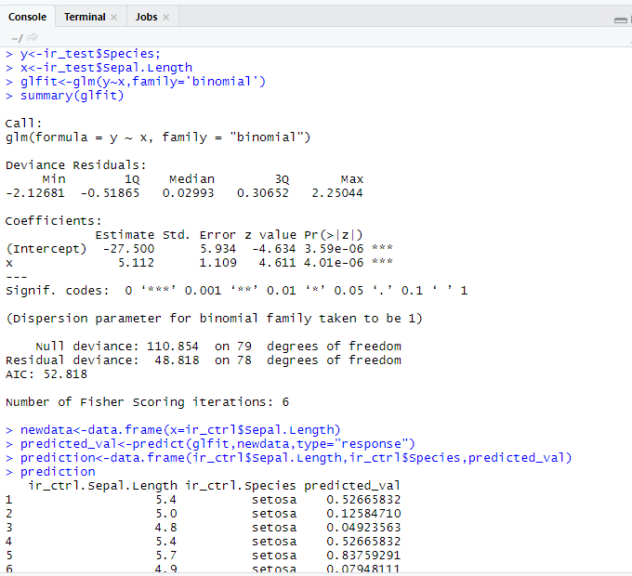

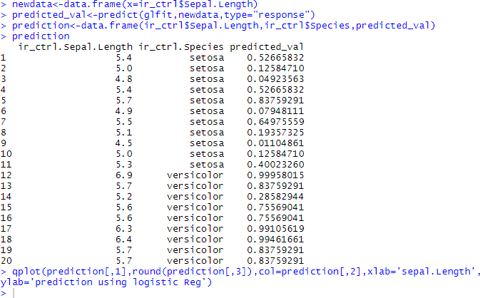
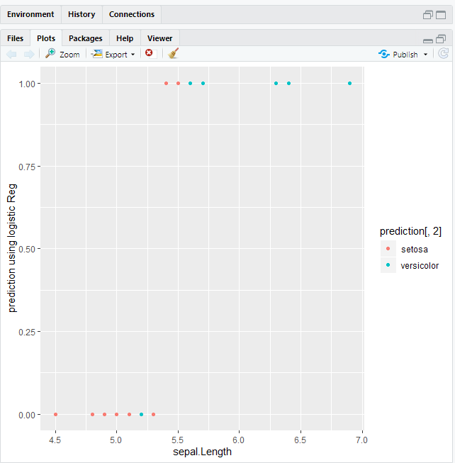

#Entering the data
Practical No. 8
Aim: Practical of Hypothesis testing
>x=c(6.2,6.6,7.1,7.4,7.6,7.9,8,8.3,8.4,8.5,8.6,8.8,8.8,9.1,9.2,9.4,9.7,9. 9,10.2,10.4,10.8,11.3,11.9)

#one-sample Hypothesis test
>t.test(x-9,alternative = "two.sided",conf.level = 0.95)

#Two-sample hypothesis test
>x=c(481,421,421,422,425,427,431,434,437,439,446,447,448,454,46 3,465)
>y=c(429,430,430,431,36,437,440,441,445,446,447)

>test2<-t.test(x,y,alternative = "two.sided",mu=0,var.equal = F,conf.level = 0.95)
>test2

Output:
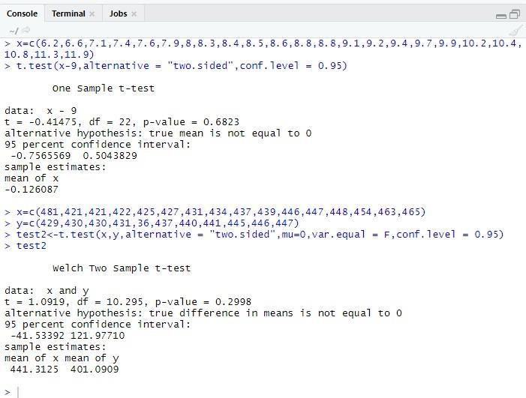

- Interpretation of the result:
The p-value (0.2998) is greater than the significance level 5%(1-0.95)
So,we conclude that the null hypothesis that the population means are equal is plausible.

ftest<-read.csv(file.choose(),sep=",",header = T) var.test(ftest$time_g1,ftest$time_g2,alternative
Practical No.9
Aim: Practical of Analysis of Variance
= "two.sided")
//one way anova names(data1) summary(data1) head(data1)
anv<-aov(formula=satindex~dept,data=data1) summary(anv)
//two way anova
data2<-read.csv(file.choose(),sep=",",header=T) names(data2) summary(data2) head(data2)
anv1<-aov(formula = satindex~dept+exp+dept*exp,data=data2) summary(anv1)

Output:
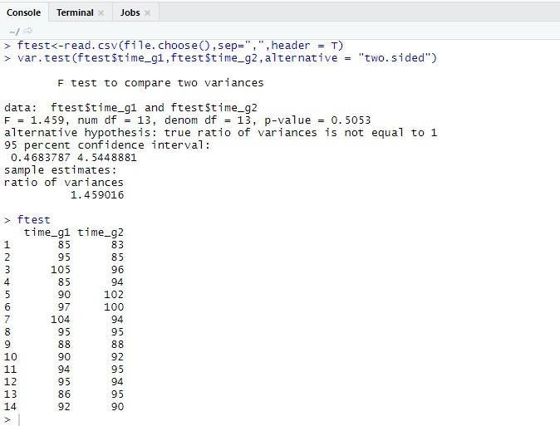

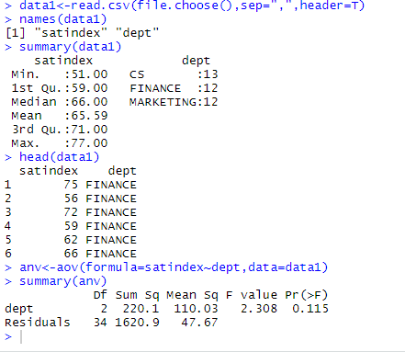

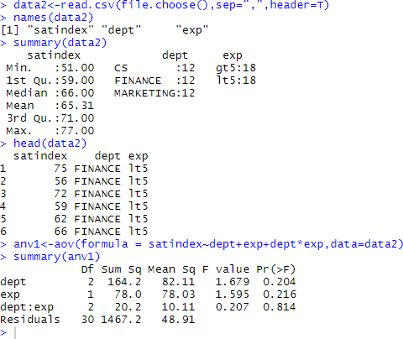

Practical No.10
mydata<-data.frame(iris) attach(mydata) install.packages("rpart") library(rpart)
model<- rpart(Species~Sepal.Length+Sepal.Width+Petal.Length+Petal.Width,da ta=mydata,method="class")
plot(model) text(model,use.n=TRUE,all=TRUE,cex=0.8) install.packages("tree")
library(tree)
model1<- tree(Species~Sepal.Length+Sepal.Width+Petal.Length+Petal.Width,data
=mydata,method="class",split="gini") plot(model1) text(model,all=TRUE,cex=0.6) install.packages("party") library(party)
model2<- ctree(Species~Sepal.Length+Sepal.Width+Petal.Length+Petal.Width,dat a=mydata) plot(model2)
library(tree)
mydata<-data.frame(iris) attach(mydata)
model<- tree(Species~Sepal.Length+Sepal.Width+Petal.Length+Petal.Width,data
=mydata,method="class",control=tree.control(nobs=150,mincut=10))

plot(model1) text(model,all=TRUE,cex=0.6) predict(model,iris)
model2<- ctree(Species~Sepal.Length+Sepal.Width+Petal.Length+Petal.Width,dat a=mydata,controls=ctree_control(maxdepth=2))
plot(model2)

Output:
